**IT24103080**

**Lab 05**

1. Import the dataset (’Exercise – Lab 05.txt’) into R and store it in a data frame called ”Delivery Times”.

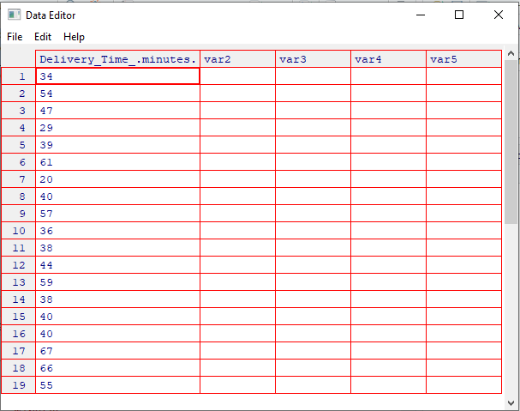

1. Draw a histogram for deliver times using nine class intervals where the lower limit is 20 and upper limit is 70. Use right open intervals.

1. Comment on the shape of the distribution.

The histogram shows a **uniform distribution**, where the frequencies across the delivery times are fairly evenly spread out across the intervals, with no clear peaks or skewness.

1. Draw a cumulative frequency polygon (ogive) for the data in a separate plot.

